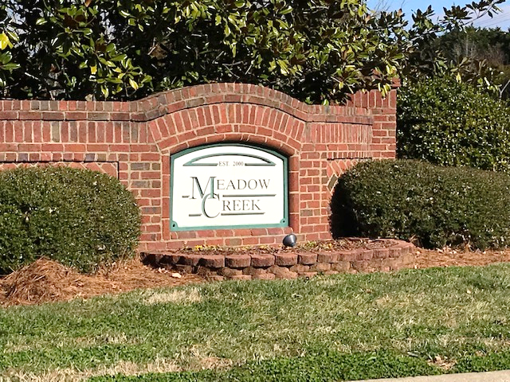
Issue
Spring 2026
S
In this issue >>>
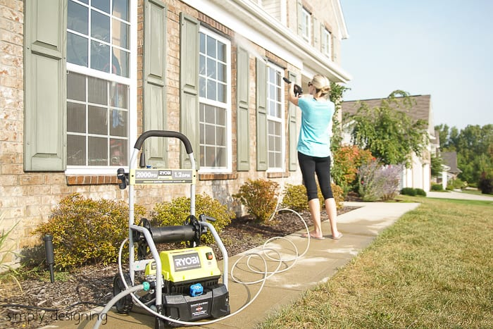
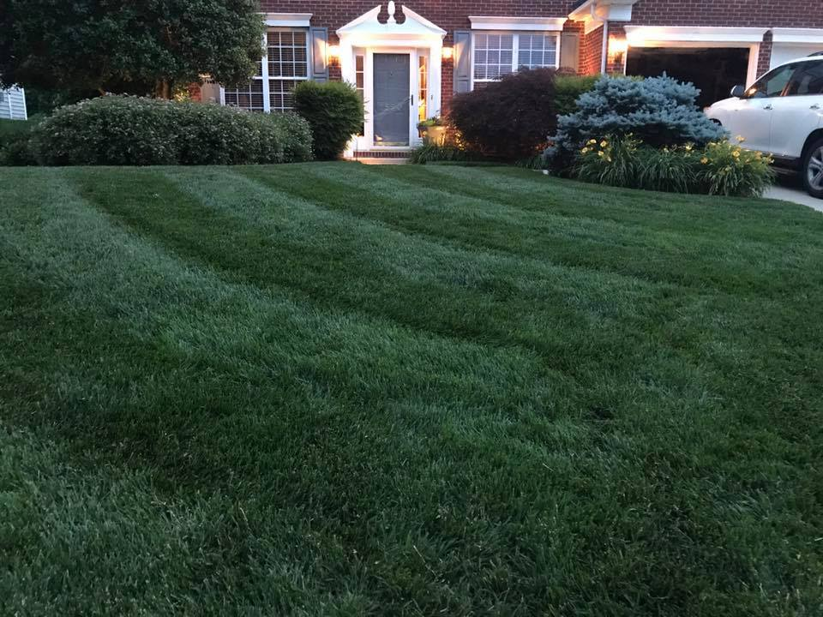

g

Community Cook-out- May 16th

Bring your family and friends to our annual cookout! Enjoy food, great company, and plenty of laughs. Don’t miss this chance to connect with fellow homeowners.

Annual Yard Sale- June 13th
Clear out the clutter and find treasures! Join your neighbors for our community yard sale. It’s a great way to socialize, shop, and enjoy a fun day in the neighborhood.

Annual Meeting- October 27th
Elk Lodge- 700 Old Mill Rd High Point, NC 27265

Your voice matters! Join us for the annual meeting to stay informed about community updates and board decisions. This is also your opportunity to get involved and run for a board position.

Upcoming Events:

Creek Subdivision
Meadow
Our HOA, Our Community Working Together

JOIN OUR FACEBOOK GROUP!

It is time to come outside and see the damage winter weather may have brought to our homes, gutters, trees, and yards.

It is Spring-Cleaning Time!

As the season changes, this is an exciting time to get ready with some “spring cleaning tips” for your home and yard. We want to help keep the community looking its best for all to enjoy as summertime approaches, and to help keep property values up.

To keep the homeowners at Meadow Creek Subdivision up to date with some of the basic upkeep and neighborly matters of the community, The Board of Directors has produced this “spring cleaning” newsletter summarizing the most frequent questions and complaints we receive from residents during the year. We hope you find it helpful.
For more information go to:

www.goldenpm.cincwebaxis.com
Current topics >>>
 Meadow creek high point
Upcoming Events
Cleaning Tips
Maintenance of Your Home
Architectural Approvals
Animals
Meet your Board…and more…
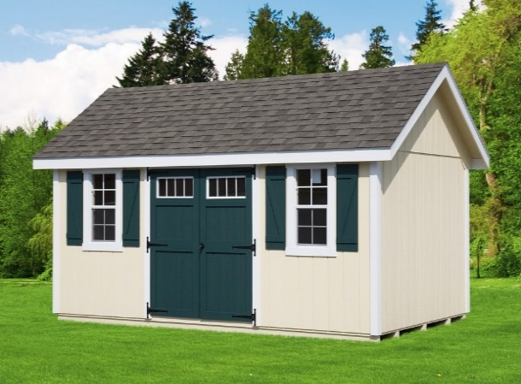
Reminders and Links >>>
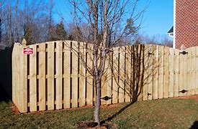

Website and Facebook
The Architectural Request Form is located on our website:
www.goldenpm.cincwebaxis.com
Forms Documents for the community can be found in the “Documents” section of the website. keep up to date with our facebook community.
In accordance with County ordinances, ‘trash containers should be removed by 7PM evening of pickup’. Please, at least do not leave out no longer than a day.
Trash cans/ (toters), garbage bags or recycling containers may only be stored in homeowners’ backyard, beside their house (concealed by an approved barrier) or inside their garage.
Please when you park your vehicle on the city street, park going with traffic as other vehicles can see the red reflection of your taillight lens.

Community Links >>>

Duke Energy – 800-777-9898 Report outage

Piedmont Natural Gas – 800-752-7504
City of High Point 336-883-3111

For more information go to:

www.meadowcreekhoa.com

An Architectural Review Request
Form must be submitted and approved BEFORE any improvement is made to your home including:

Architectural Changes
As a Board and your neighbors, we love to see you improving your homes. Whether it be a new exterior color, fence, adding a deck, or building a storage building. Did you know that per our Covenants and By-laws, approval from the Board’s architectural committee is needed before you start your project?
Paint shutters and doors – this is the time to refresh those worn out or faded shutters and front doors that have been exposed to the elements for so many years!
Pressure washing - spring is a suitable time to get the mold and winter grime off your home and fences.

Weed planting beds – Adding fresh mulch always adds an extra punch. While you are at it, why not plant some spring flowers to help add to the beauty of your yard and its curb appeal. Make sure to trim and remove old plantings around your foundation.

Reminder: Leave a minimum of one foot of clear space between plantings and foundation. Termites are prevalent in this area and keeping mulch and plants away from your foundation will help to keep the termites away.

Weather treated wood – replace old broken worn wood barrier, garden areas, fence boards and mulch.

Mowing – Prepare your mower. Clean parts, sharpen blade. When we begin the mowing season, remember to pick up the grass clippings from streets driveway and walkways.

Well maintained
doors, shutters landscaping, and
a tidy yard
will add to
a home's curb appeal.
As our homes begin to age, we can see that time has affected many parts. Now is the time to give it the loving care it needs. Let us do some cleaning and repairs to help maintain our homes, looking and working its best for our enjoyment and the beauty of our community.

Please do not leave your trash cans / toters out for more than 24hours. Place them behind approved barriers on the side of your home, in your garage or behind your home.

Trash Toters/Sanitation
Maintaining Your Home after the Winter Months:
Cleaning Tips
Property advice >>>
- Exterior painting, roof, or gutter replacement – all maintenance will be to the neighborhood standard as stated in by-laws.
- Outbuildings (sheds) - metal buildings are prohibited. One shed per Lot.
- Walls and or fences - metal fences and or poured concrete walls are prohibited.

Paperwork
Along with the request, we ask that you provide a description of the work to be done including :( paint color for shutters, doors), fence and materials to be used. It is best to err on the side of too much information.
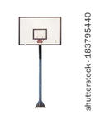
Animals
Excessive barking will disturb neighbors. Please be courteous and mind the hours your dog is outside at night. Barking is also considered a nuisance after certain hours.
Pets (dogs) need to be leashed while they are being walked throughout the neighborhood.

All animal waste must be picked up
immediately then disposed of at the
 pet owner’s property or in appropriate trash receptacles the Association provides.


Contact us at 336-887-8975 www.goldenpmanagement.com
Meet your 2026 Board Members:
President:
Julia Edwards
Vice President:
Doug Houck
Treasurer:
Bryant Davis
Secretary:
William R. Daniels
Directors:
Jeff Browning
Greg Clark

The CINC Systems homeowner portal makes it easy to stay connected with your community. Through CINC, homeowners can pay HOA assessments online, submit ACC request, work orders for issues in common areas, and access important governing documents and community information—all in one convenient place. If you have not already signed up, we encourage you to create an account and take advantage of these helpful features.
www.goldenpm.cincwebaxis.com
As a reminder the city of High Point and Guilford County Roads statue (sec.136-91): no injurious obstruction in or upon any highway or public vehicular area is allowed.
The HOA asks to keep children safe at play. Please be cautious and watch where you place basketball goals. Keep them in your driveway or on grass away from curb and street. Please make sure not to intrude on neighbors and not to cause any hazards on the streets.
Thank you.

Basketball Goals

RECYCLE CENTERS:
High Point Recycle Center:
336-883-3111
211 S. Hamilton St. High Point 27260-5321
Www. Highpointnc.gov
Tambien esta disponible en Española

Electronics: Material Recovery Facility:
336-883-3623
5875 Riverdale Drive
Jamestown, NC

Guilford County Scrap Tire: 336-294-9431
2138 Bishop Road
Greensboro, NC

ECOFLO Household
Hazardous Waste Collection Center:
2750 Patterson Street, Greensboro
1-800-999-6510

P.O. Box 16132
Greensboro, NC 27416
Golden Property Management
>>>
CINC...
Recycle Centers
Community information documents:
All documents can now be found on the website.
www.goldenpm.cincwebaxis.com
www.goldenpmanagement.com

